**3) Screenshots / API Documentation**

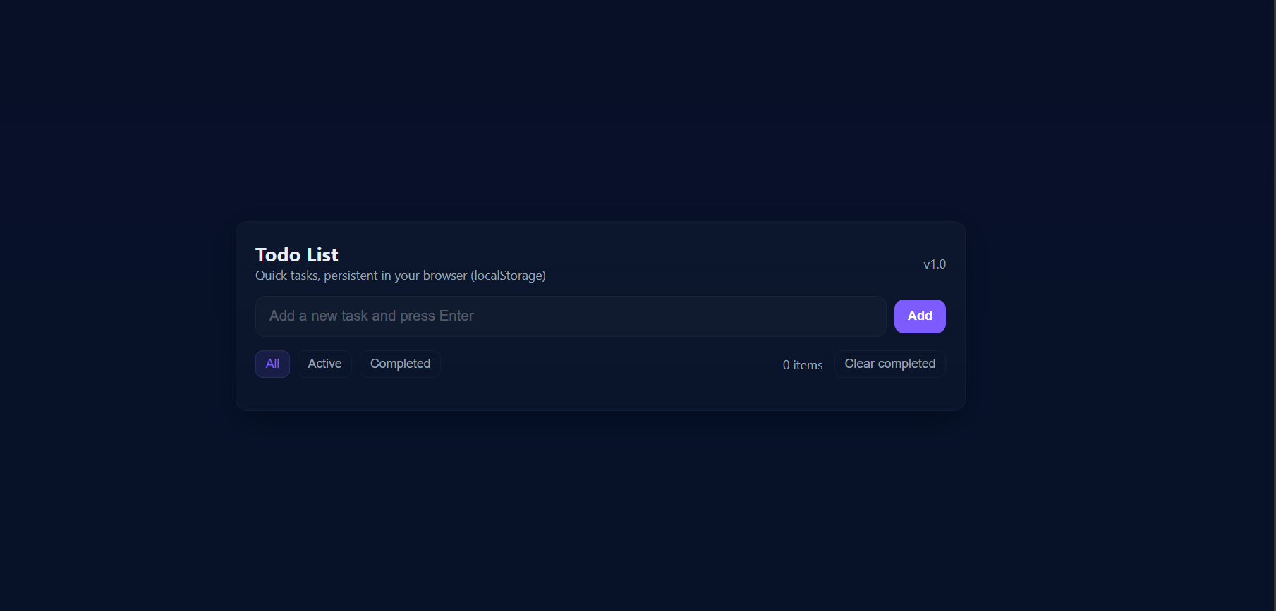

**Fig 1: Home screen**

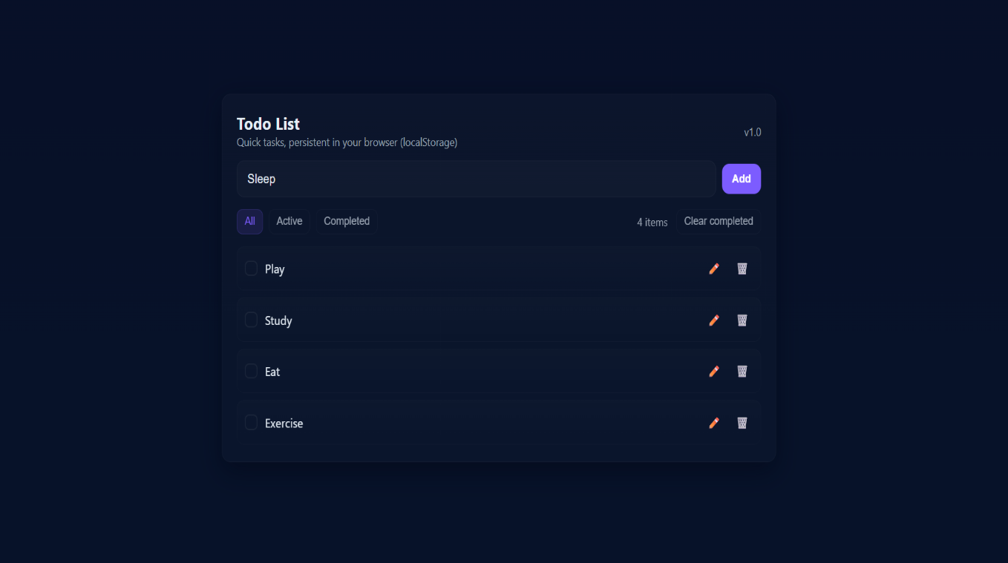

**Fig 2: Adding a new task**

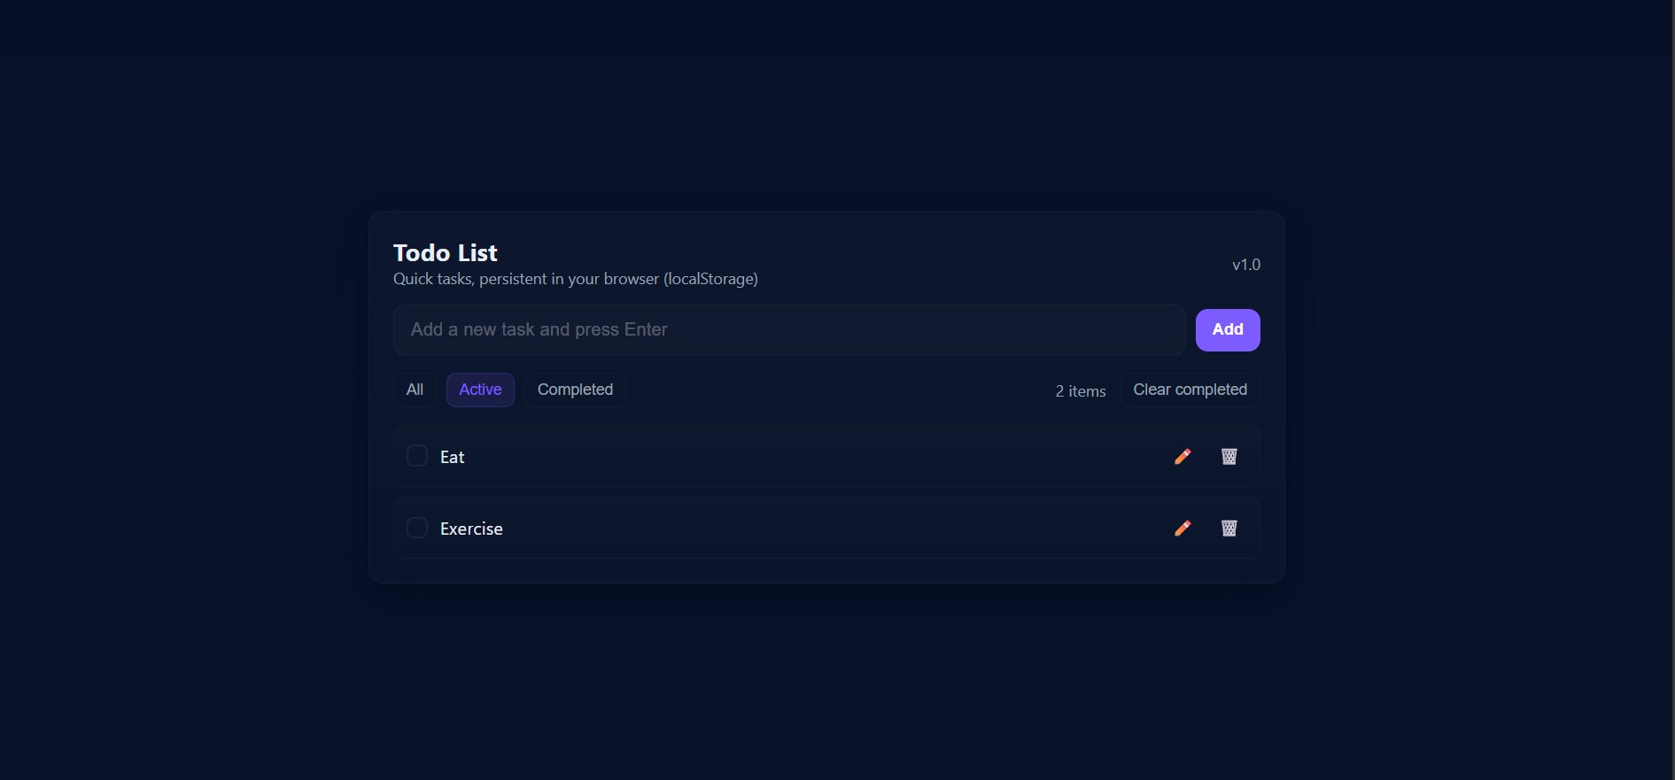

**Fig 3: Active task view**

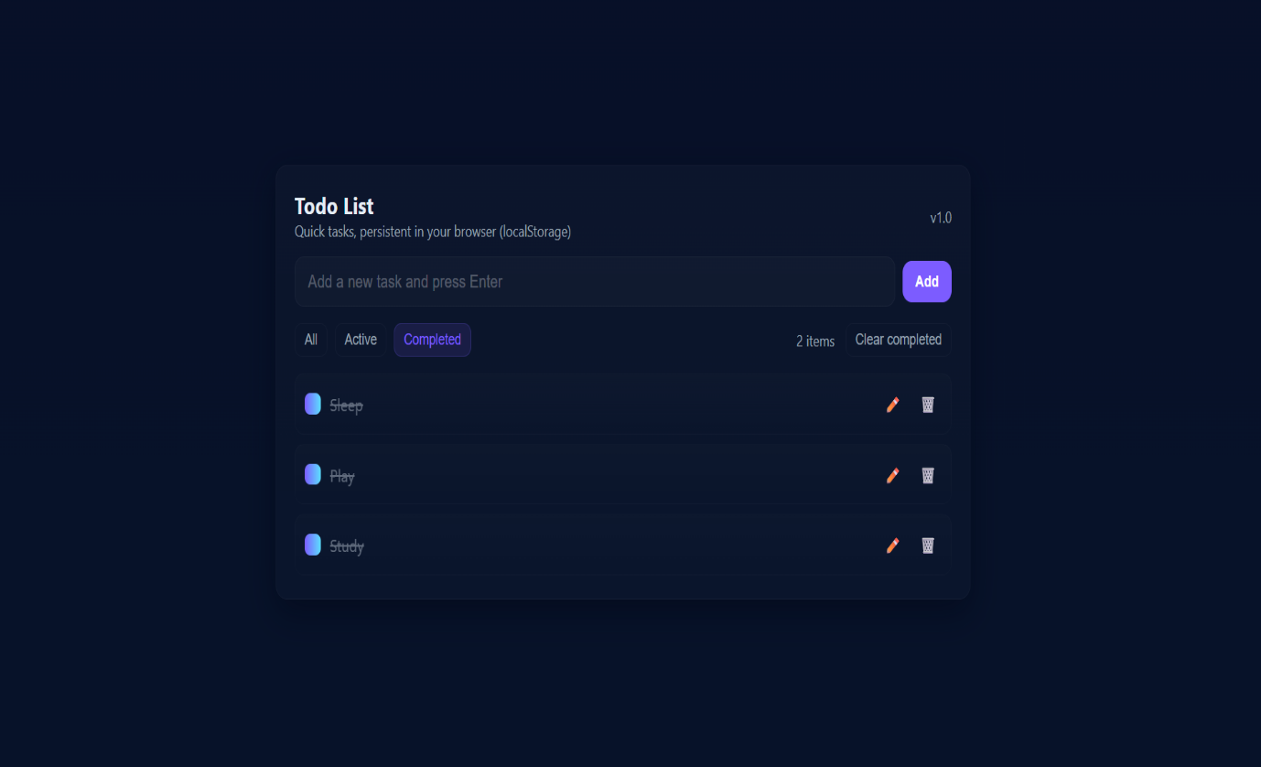

**Fig 4: Completed task view**